SEACOAST CIVIC DANCE COMPANY

Annual Gala & Auction
Saturday, March 25th, 2023
Blue Ocean Music Hall
Salisbury, MA

Levels of Sponsorship

Platinum — $1000 Donor recognition via full page ad in the program
6 tickets to the Gala ($252 value)
Recognition via NHAPA social media
Logo/Link on NHAPA’s website

Gold — $500 Donor recognition via half-page ad in the program
4 tickets to the Gala ($252 value)
Recognition via NHAPA social media
Logo/Link on NHAPA’s website

Silver — $250 Donor recognition via quarter page ad in the program
2 tickets to the Gala ($252 value)
Recognition via NHAPA social media
Logo/Link on NHAPA’s website

Bronze —$150 Donor recognition in the program

Friends & Family —$50 Donor recognition in the program

I wish to sponsor at the _________________________ level at $ __________________.

Name: ______________________________ Company: __________________________
Address: _________________________________ City: _______________ State: ____
Email: ___________________________________ Phone: ________________________
_____I will not be able to attend, please donate my sponsor tickets.

Checks made payable to SCDC
Please mail checks to:
Seacoast Civic Dance Company
875 Lafayette Road
Seabrook, NH 03875

The Seacoast Civic Dance Company

Since 1976, the Seacoast Civic Dance Company (SCDC) and Performance Groups, in partnership with NH Academy of Performing Arts, have enabled and encouraged area youth to combine a pre-professional dance education with multiple professional performance opportunities. A 501(c) (3) non-profit arts educational program, the SCDC is comprised of youth (ages 12-18) from the Seacoast of NH and Northshore of MA who have been selected for their strong performance and technical skills.

Company and Performance Group members are skilled and trained in a diverse curriculum of classes at NHAPA, including classical ballet, lyrical, contemporary, tap, jazz, and hip-hop. Company members also participate in Masterclasses, seminars, competitions, and at local and national performance venues. Past performances include Boston Celtics Pre-game, FEDEX Orange Bowl, Walt Disney World, Universal Studios, Disney Cruise Lines, the Commemoration of the 75th Anniversary of Pearl Harbor, and the 2019 Half-Time Show at the Sugar Bowl in New Orleans.

The SCDC Members donate their time, energy, and talent at all their performances despite the production costs incurred as the Directors feel strongly about giving back to the community. The organization depends greatly on the generosity of individuals and the community who sponsor the Company to offset costs associated with tuition, production, costuming, travel, master classes, and guest artists/choreographers.

Proceeds from the Spring Gala directly benefit the Company grant and scholarship program.
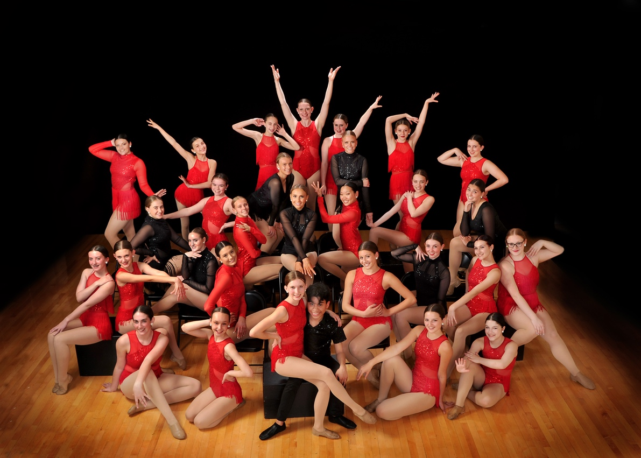

www.nhapa.org

